CSC 570R DATA SCIENCE ESSENTIALS

PREDICTING THE CAB BOOKING CANCELLATIONS

FINAL PROJECT

( Source : https://inclass.kaggle.com/c/predicting-cab-booking-cancellations2 )

SRIKAR KANAPARTHI

UIN: 658825491

NET ID : skana4@uis.edu

INTRODUCTION
The goal of this challenge is to improve customer service at YourCabs.com, a cab company in Bangalore. Some cab bookings must be cancelled by the company due to unavailability of a car (overbooking). The problem is that cancellations can occur very close to the trip start time, thereby causing inconveniences for the passengers. The task is to predict which cab bookings will most probably be cancelled, given a number of booking attributes.

DATA

The data I used here is provided by kaggle competition page.
To build and evaluate predictive models, use kaggle_yourcabs_training.csv. This file contains the outcome (0=no cancellation or 1=cancellation) and potential predictors (customer_id, car_id, from_date, to_date, from_lat, from_long, ...).

Data File: “ Kaggle_YourCabs_training.csv ”

DATA FILEDS

id - booking ID
user_id - the ID of the customer (based on mobile number)
vehicle_model_id - vehicle model type.
package_id - type of package (1=4hrs & 40kms, 2=8hrs & 80kms, 3=6hrs & 60kms, 4= 10hrs & 100kms, 5=5hrs & 50kms, 6=3hrs & 30kms, 7=12hrs & 120kms)
travel_type_id - type of travel (1=long distance, 2= point to point, 3= hourly rental).
from_area_id - unique identifier of area. Applicable only for point-to-point travel and packages
to_area_id - unique identifier of area. Applicable only for point-to-point travel
from_city_id - unique identifier of city
to_city_id - unique identifier of city (only for intercity)
from_date - time stamp of requested trip start
to_date - time stamp of trip end
online_booking - if booking was done on desktop website
mobile_site_booking - if booking was done on mobile website
booking_created - time stamp of booking
from_lat - latitude of from area
from_long - longitude of from area
to_lat - latitude of to area
to_long - longitude of to area
car_cancellation (available only in training data) - whether the booking was cancelled (1) or not (0) due to unavailability of a car.

DATA PREPARATION
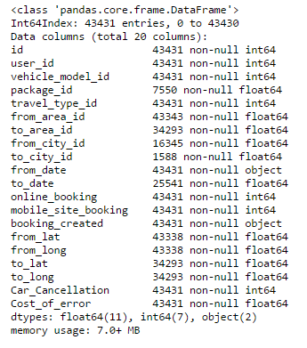
FINDING MISSING VALUES
In Dataset we find missing values for most of the columns except for two columns
package_id
from_area_id
to_area_id
from_city_id
to_city_id
to_date
from_lat
from_long
to_lat
to_long

HANDLING MISSING VALUES
Here actually we fill the missing values with the “zero” or “missing values”. Here I filled the missing values with “0”.
CLEANING OF DATA
Here I got not data to clean.
Now our Data is ready for further modeling
DATA MODELlING
This is a regression problem, here we need to predict the cab cancellations.Random forest regressor is used in this model.
Model (First Model)
For this first model I have splitted the data in to X_train, Y_train, X_test,y_test and splitted the main data in to these variables.
AUC: 0.617062000612
AUC score is 0.61. Since it's a very poor model

Model 2
For this I’ve used catergorical variables. I’ve imported date time and modified the date time. The from_date is made in to from_month , from_weekday, from_time and booking_created to booking_month,booking_weekday,booking_time.Dropped the unnecessary data like from_date, booking_time, id, user_id, to_date.
Here in the next step I reduced some of the categorical variables.Repeated the split process and calculated the AUC score.
Result: The AUC is 0.6049 and the model is still very poor
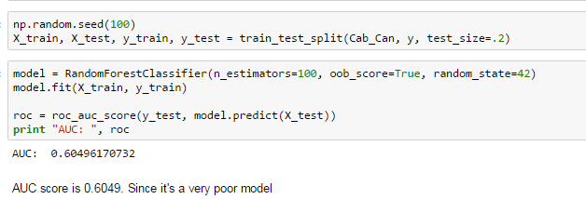
FINAL MODEL
To achieve the better results some of the parameter need to be tested and calculated.They’re as follows.
n_estimators: The number of trees in the forest.
max_features: The number of features to consider when looking for the best split.
min_samples_leaf: The minimum number of samples in newly created leaves.
n_jobs: Determines if multiple processors should be used to train and test the model.
After testing n_estimators, max_features,min_samples_leaf,n_jobs. I’ve calculated the AUC score the result as follows:
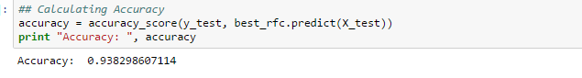
Calculating the precission and recall Confusion matrix:
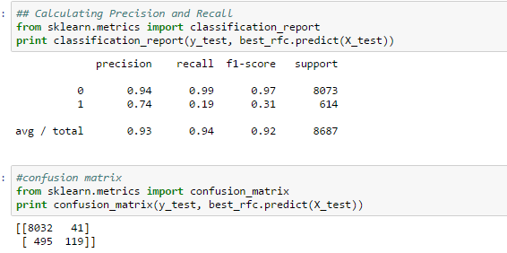
Calculating the AUC score:
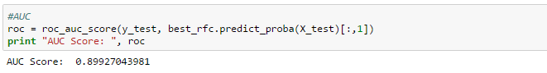
Plotting the ROC Curve:
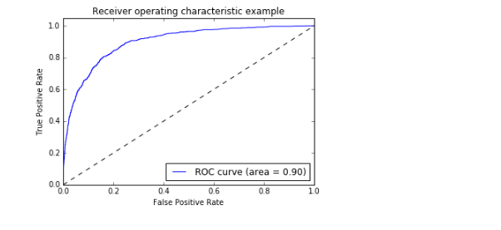

Auc Score is : 0.89927043981 ( This model approximately 90% correctly predicts the cab cancellation ) before the K-Fold cross validation

K-Fold Cross Validation
Split the data into K chunks Train K models, retain a chunk for testing and use the other K-1 chunks for training. The result is K scores, which can be combined into a single average score for the model.
Results after K-Fold CV:
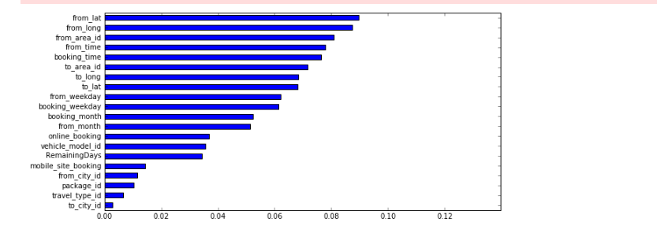

THE RESULTS

Precision and Recall
Precision is ratio of true positives to all positives. Recall is the fraction of observations classified in that class that was correctly classified. Where high precision relates to a 'low false positive rate', and high recall relates to a 'low false negative rate'. High scores for both show that the classifier is returning accurate results (high precision), as well as returning a majority of all positive results (high recall).
The model has 93% of perfection in identigying cab cancellation and a 7% chance it will show false report. (tp / tp+fp)
From this 94% of the cabs will cancelled.Final model has 6% of the times that it cant identify a cancelled booking currently . (tp / tp + fn)
CONFUSION MATRIX
tp=8032
fp=41
fn=495
Results due to error:
fnx100=>495x100=49500 units
fpx1=>41x1=40units
AUC SCORE
Auc Score is : 0.89927043981 ( This model approximately 90% correctly predicts the cab cancellation )
PERFORMANCE OF THE MODEL
AUC score was 0.899. But, after K-Fold Cross Validation it is clear that our model was overfitting.
AUC of the final model would be between 0.602617 and 0.929990.
Average K-Fold CV Score is 0.766303
CONCLUSION
This model approximately 90% correctly predicts the cab cancellation and 10% shows non-cancelled cabs as cancelled . The AUC score score in the final model will be between 0.602617 and 0.929990. Average K-Fold CV Score is 0.766303.AUC score was 0.899. But, after K-Fold Cross Validation it is clear that our model was overfitting.

REFERENCES:
https://inclass.kaggle.com/c/predicting-cab-booking-cancellations2
http://stats.stackexchange.com/questions/132777/what-does-auc-stand-for-and-what-is-it,
http://mlwiki.org/index.php/ROC_Analysis
http://scikit-learn.org/stable/modules/cross_validation.html

